Inception module V3_batch

0. Environment

|  |  |
| --- | --- |
| DataSet | CIFAR-10 |
| Language | Python3.5 & Tensorflow 1.0 |
| optimizer | Adam |
| Loss function | Cross entropy Loss |

Input : 32x32x3 size image

1. initialize

|  |  |
| --- | --- |
| layer | max_pool(stride = 2, pool_size = 2, pad) |
| output | 16x16x3 |
| layer | 1x1 conv (filter = 64) |
| output | 16x16x64 |

2. module (10 times)

|  |  |  |  |  |
| --- | --- | --- | --- | --- |
| layer | 1x1 conv  (fileter = 16) | 1x1 conv  (fileter = 16) | 1x1 conv  (fileter = 16) | batch_norm |
| 3x3 conv  (filter = 16, pad) | 3x3 conv  (filter = 16, pad) | 1x1 conv  (filter = 16, pad) |
| 3x3 conv  (filter = 16, pad) |
| output | 16x16x16 | 16x16x16 | 16x16x16 | 16x16x16 |
| concatenate | 16x16x64 | | | |
| Layer | relu | | | |
| output | 16x16x64 | | | |

3.Fully connected

|  |  |
| --- | --- |
| layer | Affine (W = 16x16x64,1024) |
| output | 1024 |
| layer | Affine (W = 1024, 10) |
| output | 10 |

4. Overall

|  |  |
| --- | --- |
| Training(7600 iteration) | Time : 4729.098791360855 seconds |
| Accuracy : 0.713 |
| Validation | Accuracy : 0.634 |
| Re-training(64 iteration) | Accuracy : 0.686 |
| Re-Validation | Accuracy : 0.628 |
| Test | Acurracy : 0.604 |

Training

Iteration 0: with minibatch training loss = 3.25 and accuracy of 0.19

Iteration 100: with minibatch training loss = 1.99 and accuracy of 0.28

Iteration 200: with minibatch training loss = 1.69 and accuracy of 0.42

Iteration 300: with minibatch training loss = 1.66 and accuracy of 0.44

Iteration 400: with minibatch training loss = 1.75 and accuracy of 0.38

Iteration 500: with minibatch training loss = 1.45 and accuracy of 0.42

Iteration 600: with minibatch training loss = 1.58 and accuracy of 0.34

Iteration 700: with minibatch training loss = 1.73 and accuracy of 0.38

Epoch 1, Overall loss = 2.19 and accuracy of 0.399

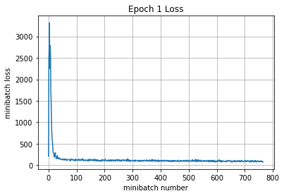

Iteration 800: with minibatch training loss = 1.6 and accuracy of 0.39

Iteration 900: with minibatch training loss = 1.2 and accuracy of 0.53

Iteration 1000: with minibatch training loss = 1.47 and accuracy of 0.48

Iteration 1100: with minibatch training loss = 1.47 and accuracy of 0.38

Iteration 1200: with minibatch training loss = 1.26 and accuracy of 0.58

Iteration 1300: with minibatch training loss = 0.982 and accuracy of 0.67

Iteration 1400: with minibatch training loss = 1.44 and accuracy of 0.44

Iteration 1500: with minibatch training loss = 1.12 and accuracy of 0.67

Epoch 2, Overall loss = 1.3 and accuracy of 0.532

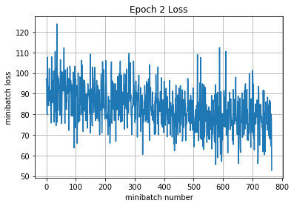

Iteration 1600: with minibatch training loss = 1.19 and accuracy of 0.55

Iteration 1700: with minibatch training loss = 1.3 and accuracy of 0.52

Iteration 1800: with minibatch training loss = 1.16 and accuracy of 0.61

Iteration 1900: with minibatch training loss = 1.18 and accuracy of 0.47

Iteration 2000: with minibatch training loss = 1.04 and accuracy of 0.64

Iteration 2100: with minibatch training loss = 1.15 and accuracy of 0.5

Iteration 2200: with minibatch training loss = 1.22 and accuracy of 0.62

Epoch 3, Overall loss = 1.16 and accuracy of 0.588

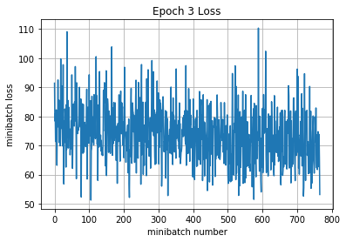

Iteration 2300: with minibatch training loss = 1.19 and accuracy of 0.61

Iteration 2400: with minibatch training loss = 1.15 and accuracy of 0.62

Iteration 2500: with minibatch training loss = 1.19 and accuracy of 0.55

Iteration 2600: with minibatch training loss = 1.21 and accuracy of 0.61

Iteration 2700: with minibatch training loss = 1.1 and accuracy of 0.58

Iteration 2800: with minibatch training loss = 0.919 and accuracy of 0.7

Iteration 2900: with minibatch training loss = 0.949 and accuracy of 0.59

Iteration 3000: with minibatch training loss = 1.03 and accuracy of 0.66

Epoch 4, Overall loss = 1.07 and accuracy of 0.62

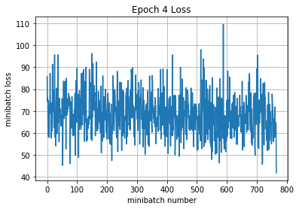

Iteration 3100: with minibatch training loss = 1.55 and accuracy of 0.47

Iteration 3200: with minibatch training loss = 0.967 and accuracy of 0.61

Iteration 3300: with minibatch training loss = 0.753 and accuracy of 0.77

Iteration 3400: with minibatch training loss = 1.4 and accuracy of 0.53

Iteration 3500: with minibatch training loss = 0.812 and accuracy of 0.77

Iteration 3600: with minibatch training loss = 1.03 and accuracy of 0.64

Iteration 3700: with minibatch training loss = 1.01 and accuracy of 0.64

Iteration 3800: with minibatch training loss = 1.14 and accuracy of 0.61

Epoch 5, Overall loss = 1.01 and accuracy of 0.644

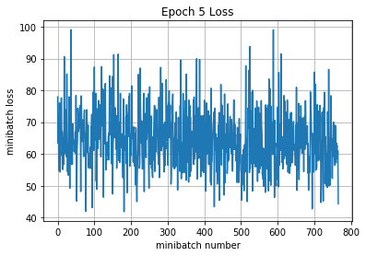

Iteration 3900: with minibatch training loss = 0.979 and accuracy of 0.56

Iteration 4000: with minibatch training loss = 0.905 and accuracy of 0.73

Iteration 4100: with minibatch training loss = 0.983 and accuracy of 0.59

Iteration 4200: with minibatch training loss = 1.26 and accuracy of 0.58

Iteration 4300: with minibatch training loss = 0.96 and accuracy of 0.69

Iteration 4400: with minibatch training loss = 0.835 and accuracy of 0.64

Iteration 4500: with minibatch training loss = 0.938 and accuracy of 0.69

Epoch 6, Overall loss = 0.965 and accuracy of 0.658

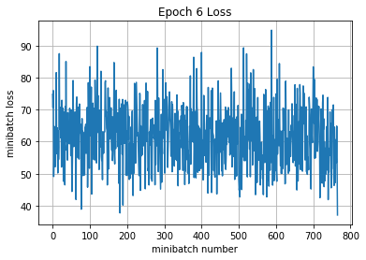

Iteration 4600: with minibatch training loss = 0.81 and accuracy of 0.64

Iteration 4700: with minibatch training loss = 1.11 and accuracy of 0.66

Iteration 4800: with minibatch training loss = 0.842 and accuracy of 0.66

Iteration 4900: with minibatch training loss = 1.15 and accuracy of 0.67

Iteration 5000: with minibatch training loss = 0.717 and accuracy of 0.72

Iteration 5100: with minibatch training loss = 0.935 and accuracy of 0.64

Iteration 5200: with minibatch training loss = 0.835 and accuracy of 0.73

Iteration 5300: with minibatch training loss = 0.819 and accuracy of 0.64

Epoch 7, Overall loss = 0.923 and accuracy of 0.672

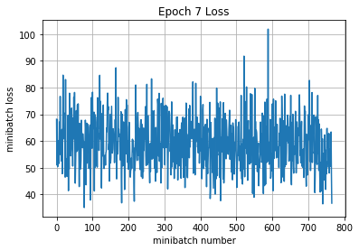

Iteration 5400: with minibatch training loss = 0.78 and accuracy of 0.75

Iteration 5500: with minibatch training loss = 0.889 and accuracy of 0.69

Iteration 5600: with minibatch training loss = 0.838 and accuracy of 0.67

Iteration 5700: with minibatch training loss = 0.871 and accuracy of 0.7

Iteration 5800: with minibatch training loss = 0.894 and accuracy of 0.67

Iteration 5900: with minibatch training loss = 0.795 and accuracy of 0.69

Iteration 6000: with minibatch training loss = 0.945 and accuracy of 0.62

Iteration 6100: with minibatch training loss = 0.732 and accuracy of 0.73

Epoch 8, Overall loss = 0.884 and accuracy of 0.686

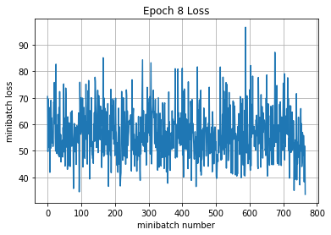

Iteration 6200: with minibatch training loss = 0.723 and accuracy of 0.73

Iteration 6300: with minibatch training loss = 0.853 and accuracy of 0.7

Iteration 6400: with minibatch training loss = 0.722 and accuracy of 0.73

Iteration 6500: with minibatch training loss = 0.954 and accuracy of 0.7

Iteration 6600: with minibatch training loss = 0.83 and accuracy of 0.73

Iteration 6700: with minibatch training loss = 1.1 and accuracy of 0.64

Iteration 6800: with minibatch training loss = 0.954 and accuracy of 0.67

Epoch 9, Overall loss = 0.845 and accuracy of 0.699

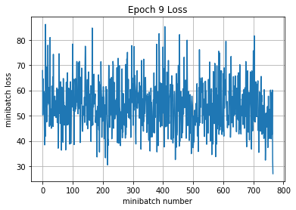

Iteration 6900: with minibatch training loss = 0.677 and accuracy of 0.73

Iteration 7000: with minibatch training loss = 0.927 and accuracy of 0.7

Iteration 7100: with minibatch training loss = 0.637 and accuracy of 0.84

Iteration 7200: with minibatch training loss = 0.874 and accuracy of 0.59

Iteration 7300: with minibatch training loss = 1.11 and accuracy of 0.58

Iteration 7400: with minibatch training loss = 0.716 and accuracy of 0.73

Iteration 7500: with minibatch training loss = 0.871 and accuracy of 0.72

Iteration 7600: with minibatch training loss = 0.801 and accuracy of 0.75

Epoch 10, Overall loss = 0.813 and accuracy of 0.713

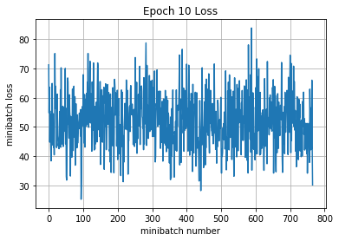

4729.098791360855

Validation

Epoch 1, Overall loss = 1.13 and accuracy of 0.634

Training

Epoch 1, Overall loss = 0.889 and accuracy of 0.686

Validation

Epoch 1, Overall loss = 1.15 and accuracy of 0.628

Test

Epoch 1, Overall loss = 1.19 and accuracy of 0.604